**WAGNER—**Opening – 15 (Horn in F)

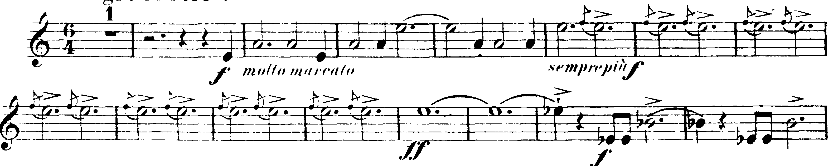

**TCHAIKOVSKY—**Mvt II: 8 – 28 (Horn in F)

